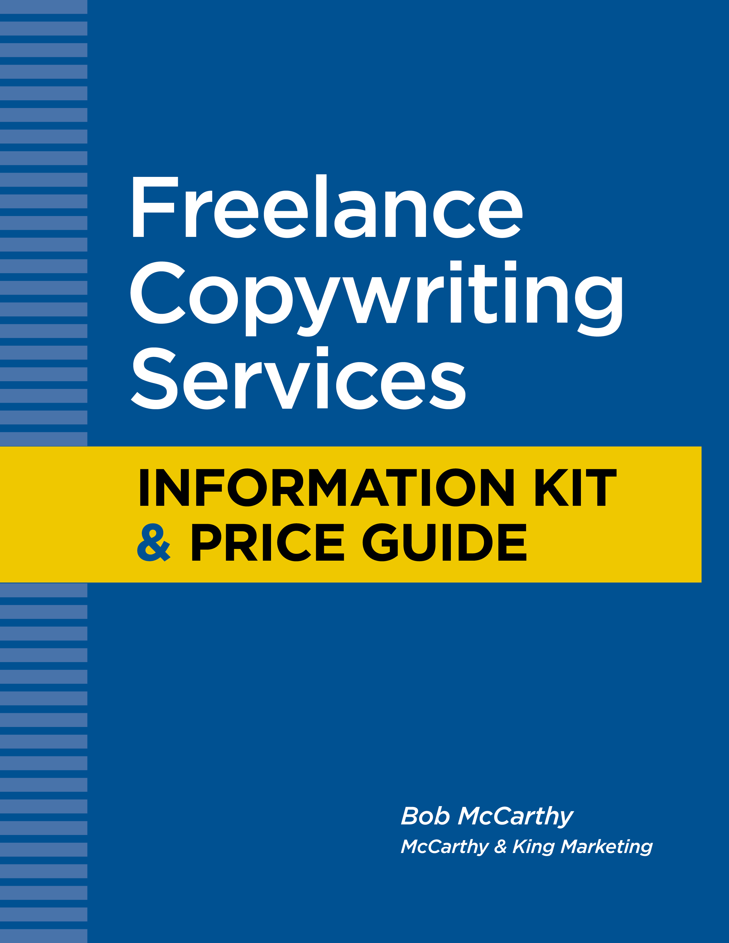
Freelance Copywriting Services
Bob McCarthy – 508-473-8643

Welcome


My name is Bob McCarthy and I am a freelance copywriter.

I’ve been freelancing for close to 30 years, first as a direct mail copywriter, and now also as an email and web writer.

My experience crosses many industries including the non-profit world.

Over the years, I have written dozens of fundraising appeals and various marketing collateral for many non-profits.

Most of my non-profit work is direct mail as you see from the enclosed booklet.

In addition to my copywriting services, I can also provide graphic design and, when needed, full-service direct mail campaigns.

Please call me or send me an email if you have a project to discuss, or if you just want to get acquainted.

Thank you.

Bob McCarthy
508-473-8643
bob@mccarthyandking.com

Bob McCarthy - Bio

Since the early 1980s, Bob McCarthy has been writing copy for business and non-profits. His work includes many direct mail fundraising packages for donor acquisition, donor renewal and donor communications.

Bob has been active in the direct marketing industry throughout his career. He is a past president of the New England Direct Marketing Association (NEDMA).

Bob began his career in journalism working as a reporter for the Quincy Patriot Ledger. He later handled public relations for Quincy, Massachusetts’ 1976 bicentennial celebration, the New England Interstate Water Pollution Control Commission and the Massachusetts Office of Coastal Zone Management.

In 1980, he became a copywriter for The DR Group, one of the nation’s first direct marketing agencies. Four years later, he left the agency to work as a freelancer. He is currently president of McCarthy & King Marketing, Inc., in Milford, Massachusetts.

In addition to his client work, Bob spent 10 years teaching direct response copywriting at the Bentley College (Waltham, MA) Direct Marketing Program, and two years teaching mailing list research at the Merrimack College (Andover, MA) Direct Marketing Program.

Bob is a Massachusetts native and a graduate of Northeastern University (Boston, MA).

Non-Profit Experience
UMass ALS Champion Fund | New England Community Health Centers
ALS Association | National Asthma Hospital
International Myeloma Foundation | National Jewish Hospital
Scottish Rite Blue Envelope Appeal | CATS (homeless treatment services)
Scottish Rite Family Life | Spruce Home (for troubled youth)
New Hampshire Forest Society | Kendall Whaling Museum
Lahey Clinic | Children’s Learning Centers (for dyslexia)
Olympics - USA Cycling | Olympics - USA Shooting
National Fire Protection Association | Irish American Partnership
Syrian-American Medical Society Foundation

Non-Profit Clients and Projects
Bob McCarthy – 508-473-8643

National Fire Protection Association
Wrote a direct mail letter order generation package to sell an industry publication
Wrote a direct mail letter package to promote a fire code subscription service
Wrote a direct mail letter package to reactivate lapsed customers
ALS Association
Wrote newsletter to keep current donors informed of research progress.
Leahy Clinic
Wrote multiple direct mail letter packages to support the hospital’s fundraising efforts.
Milford Community Program
Wrote multiple web pages to promote various community activities
Wrote multiple direct mail self-mailers for summer camps and adult education
Wrote multiple email campaigns to promote activities to opt-in customers and prospects
Wrote flyers, banners, surveys

Babson College
Wrote a direct mail survey to identify potential candidates for executive education
Wrote a direct mail postcard to promote the program

Scottish Rite of Freemasonry
Wrote the annual fundraising package for 10 years in a row
Wrote the supporting information kit for local chapters
Wrote multiple communications from headquarters to its chapters
Wrote and organized a multi-section activity and promotion binder for local chapters

New Hampshire Forest Society
Wrote and designed a direct mail letter package to solicit donations and raise awareness of the state’s resources

New England Community Health Centers
Wrote a direct mail letter package to recruit physicians to work in community health centers

Kendall Whaling Museum
Wrote a mini-catalog promoting various products available from the museum

Children¹s Learning Centers (for children with dyslexia)
Wrote and designed a direct mail letter/brochure package to support the program’s fundraising efforts. This program provides specialized education to children with dyslexia. Also wrote and designed two annual reports for this organization.

Community Awareness and Treatment Services (CATS)
Wrote a direct mail letter/brochure package to increase awareness and raise funds for this San Francisco-based program serving the homeless population.

Olympics – USA Cycling
Wrote a direct mail fundraising letter to raise money for the USA Olympic Cycling Team

Olympics – USA Shooting
Wrote multiple mailings to support the fundraising efforts of the USA Olympic Shooting Team

UMass ALS Champion Fund
Wrote and designed a direct mail letter/brochure package to support the program’s fundraising efforts. This program supports ALS research under the name of Gov. Paul Cellucci who died from ALS in 2013.

International Myeloma Foundation
Wrote a direct mail letter packages for both donor acquisition and renewals. IMF supports research into this relatively rare blood disease.

The Irish American Partnership
Wrote and designed an eight-page newsletter updating donors on current grants and outcomes that resulted from their donations.

National Asthma Hospital
Wrote two donor renewal and donor acquisition direct mail letters

National Jewish Hospital
Wrote donor renewal and acquisition letter for the hospital’s Annual Fund.

Syrian-American Medical Society (SAMS) Foundation
Wrote a direct mail acquisition letter to generate first-time donations

Writing Samples

ALS Champion Fund

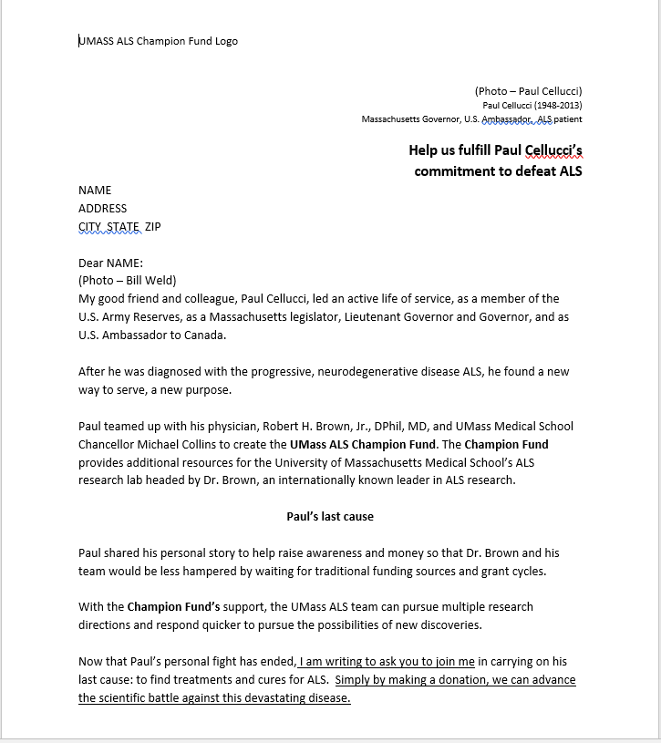

Lahey Clinic

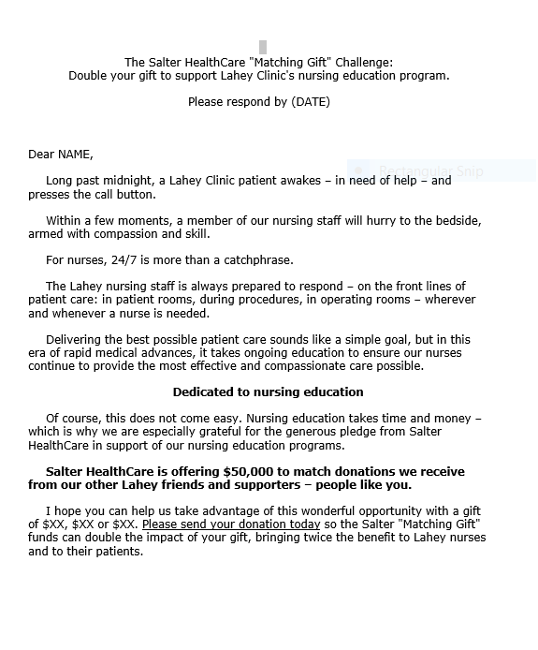

International Myeloma Foundation

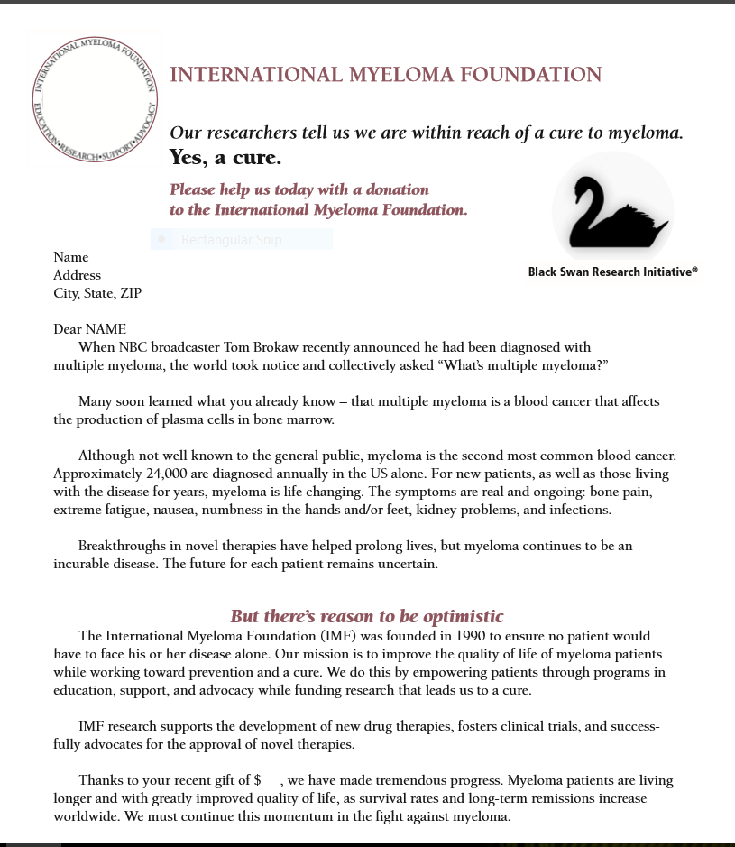

CATS

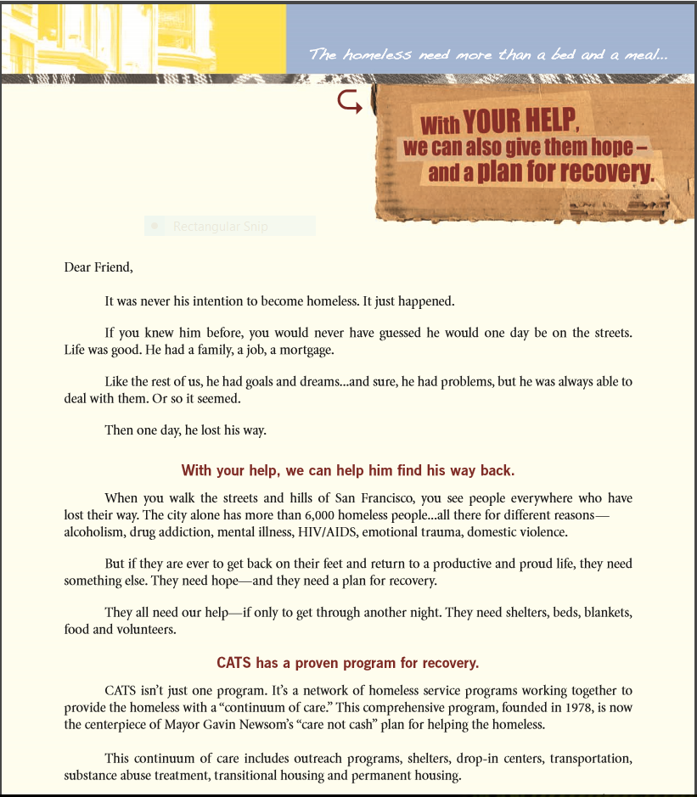

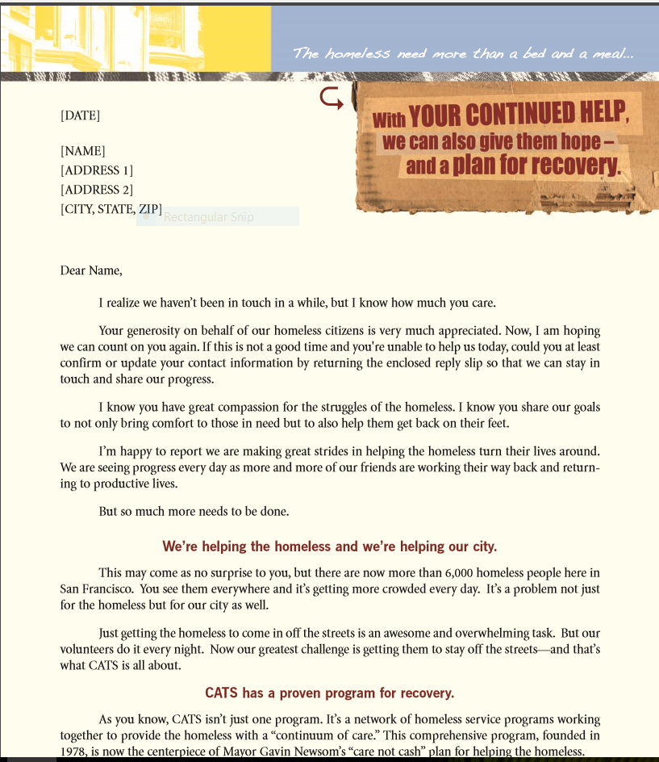

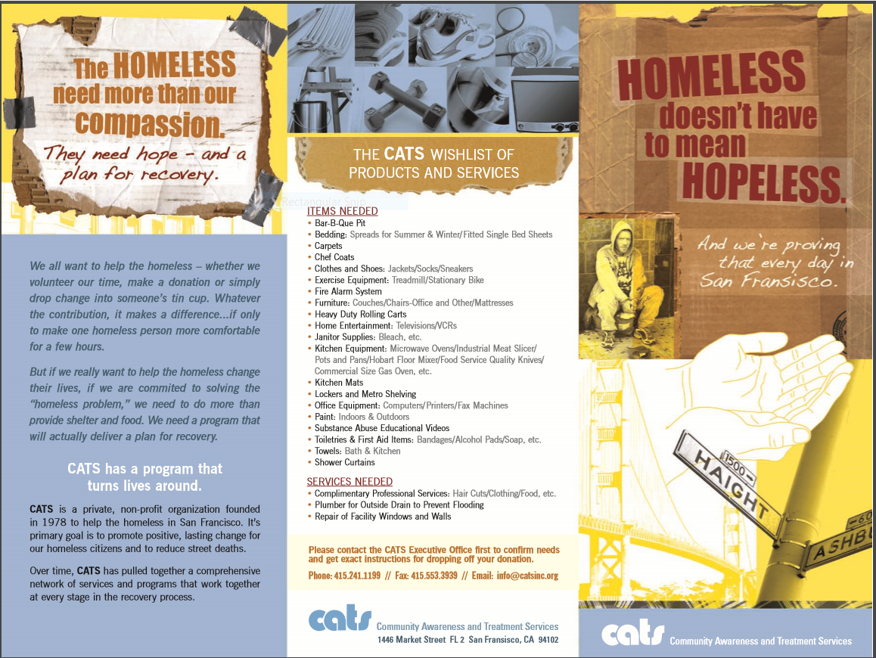
Children’s Learning Centers

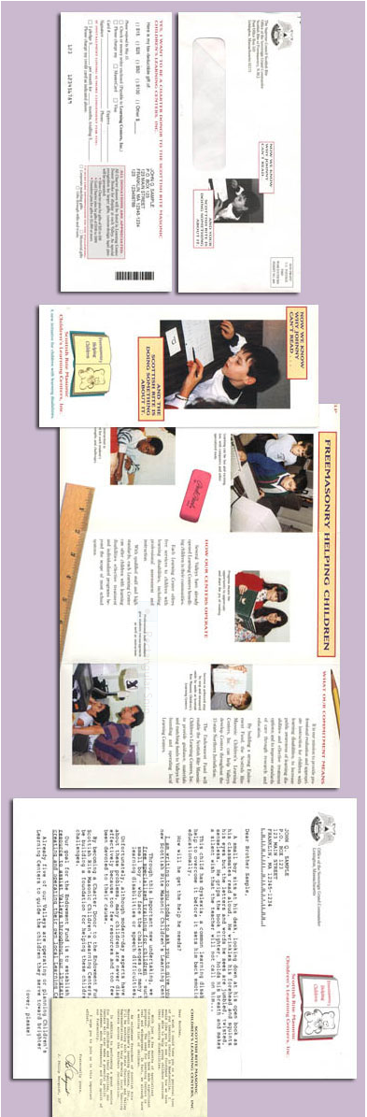
Copywriting Fee Schedule
Bob McCarthy – 508-473-8643
(fees as 10/26/16 – subject to change)

DIRECT MAIL
Direct mail letter packages
- Letter/reply only $1,200 - $1,500
- Letter/reply with brochure $2,200 - $3,000

Self-mailers (3 panels)
- Small, each panel 8.5x5.5 $1,200 - $1,600
- Large, each panel 8.5x11 $2,200 - $3,000

Postcards
- Small, 4x6 $ 600 - $ 800
- Large 6x11 $1,000 - $1,200

Booklet mailers
- Small, each page 8.5x5.5 $250 per page
- Large, each page 8.5x11 $400 per page

Lead generation survey mailer
- Letter/1-page survey $ 800 - $1,100
- Letter/2-page survey $1,200 - $1,500

Billing Stuffers 3.5x8.5 – 2 sides $ 600 - $ 800

WEB
Landing pages
- Lead capture/short message $ 400 - $ 600
- Lead capture/long message $1,000 - $1,500

Web pages
- 1-2 screen views $ 500 per page
- 2+ screen views $ 800 per page

SEO & keyword copywriting/editing (existing pages) $ 250 per page

Website planning/organization/content outline (no writing)
- 10 pages $1,000
- 20 pages $1,800

PRINT & ONLINE ADVERTISING
Full-page print ad (8x10) $ 800 - $1,000

Half-page and smaller print ad $ 400 - $ 800

Printed insert (8.5x11, both sides) $1,200 - $1,600

Online banner ad $ 400 - $ 800

Pay per click text ads (10 versions provided) $ 400

IDEA GENERATION
Up to 10 creative concepts, themes, headlines, teasers or titles $ 800

COLLATERAL/SALES SUPPORT
Brochures (3 panels)
- Small, each panel 8.5x5.5 $1,200 - $1,600
- Large, each panel 8.5x11 $2,200 - $3,000

Sell sheets/Product sheets (8.5x11)
- One side $ 800 - $1,000
- Two-sides $1,200 - $1,600

Lead qualification surveys (2 pages) $ 600 - $1,000
Customer satisfaction surveys (2 pages) $ 600 - $1,000

Telephone scripts/call guides – prospecting $ 800 - $1,000
Telephone scripts/call guides - selling $1,200 - $1,500

PowerPoint presentation $ 600 - $1,000

Product packaging $ 400 - $ 600

PUBLIC RELATIONS
- Press Releases $ 400 - $ 600
- Media Kits $1,200
EMAIL
Solo email for prospecting
- Long form – sales focused $1,000 - $1,200
- Short form – lead focused $ 600 - $ 800

Auto-responder email series for lead nurturing
- 1-2 emails $ 650 per email
- 3-6 emails $ 550 per email
- 7-10 emails $ 450 per email

Email newsletter (1-2 articles per issue) $1,000 - $2,000

Transactional email templates $ 400 per email
Situational email templates $ 400 per email
Sales follow-up email templates $ 400 per email

CONTENT MARKETING
Reports/Whitepapers/How-To Guides
- Formatting and writing $ 400 per page
- Formatting and editing (client provides writing) $ 250 per page

Case Studies/Client Interviews/Executive Profiles
- Research, interviewing $ 600
- Formatting and writing $1,000 - $1,500

Blog Writing
- Content planning/calendar development $1,200
- Write blog posts (500 words) $ 400 per post
- Edit blog posts (500 words) $ 250 per post

How I work
- Every job gets an estimate. Unless you change the specifications, the estimate and the final invoice should be the same.
- Estimate will cover my time for
  - client input
  - research
  - concepts
  - message outline
  - writing
  - revisions
  - coordination with a graphic designer (if needed)
- I do not put a limit on revisions. I want you happy with the finished product. Fortunately, most projects only need one or two revisions.
- Most projects are handled by phone, email and online conference call. I am happy to meet with you in person if it’s convenient.

How payment is handled
For projects that are less than $3,000, we bill in two parts:

50% deposit – billed on approval of project
50% balance – billed on completion of project (or 30 days later whichever comes first)
Larger jobs are billed in three installments.

Thanks - Bob McCarthy
.

